Kenneth Nyangweso

ENERGY CONSUMPTION PREDICTION

BUSINESS UNDERSTANDING

PROJECT OVERVIEW :

Energy demand forecasting is critical for efficient power generation, distribution, and cost management. Accurate predictions help utility providers and energy stakeholders optimize resource allocation, reduce operational costs, and ensure grid stability.
In this project, I focused on building predictive models that can estimate future energy consumption using both historical trends and engineered features.

PROBLEM STATEMENT :

The goal of this project is to develop models capable of accurately predicting hourly energy consumption.
The challenge lies in:
- Capturing temporal patterns in energy usage
- Handling seasonality and trends
- Leveraging both historical consumption and engineered features

OBJECTIVES :

- Build machine learning and deep learning models for energy prediction
- Compare performance across different modeling approaches
- Improve prediction accuracy using feature engineering
- Deploy a functional application for real-time predictions

METRICS OF SUCCESS :

The models were evaluated using:
- RMSE (Root Mean Squared Error) → penalizes large errors
- MAE (Mean Absolute Error) → measures average error
- R² Score → explains variance captured by the model
Success was defined by:
- Low RMSE ( < 800 MW)
- Low MAE ( < 500 MW )
- High R² score ( > 90 % )
- Consistent predictions across test data

DATA UNDERSTANDING

DATASET OVERVIEW :

The dataset was sourced from Kaggle website and consists of the following columns :
- Date time
- Energy consumption in Megawatts (MW)

DATA CLEANING AND FEATURE ENGINEERING:

DATA CLEANING :

The dataset underwent the following cleaning steps:
- Handling missing values
- Ensuring correct datetime formatting
- Removing duplicates
- Verifying consistency in time intervals

FEATURE ENGINEERING :

Feature engineered features include :

- Time-Based Features
  - year, month, day, day_of_week, hour
- Lag Features
  - lag_1 → previous hour consumption
  - lag_24 → same hour previous day
  - lag_168 → same hour previous week
- Rolling Statistics
  - rolling_mean_24 → 24-hour average
  - rolling_mean_168 → 7-day average
These features help capture short-term and long-term temporal dependencies.

EXPLORATORY DATA ANALYSIS :

EDA was conducted to uncover patterns and trends:

UNIVARIATE ANALYSIS :

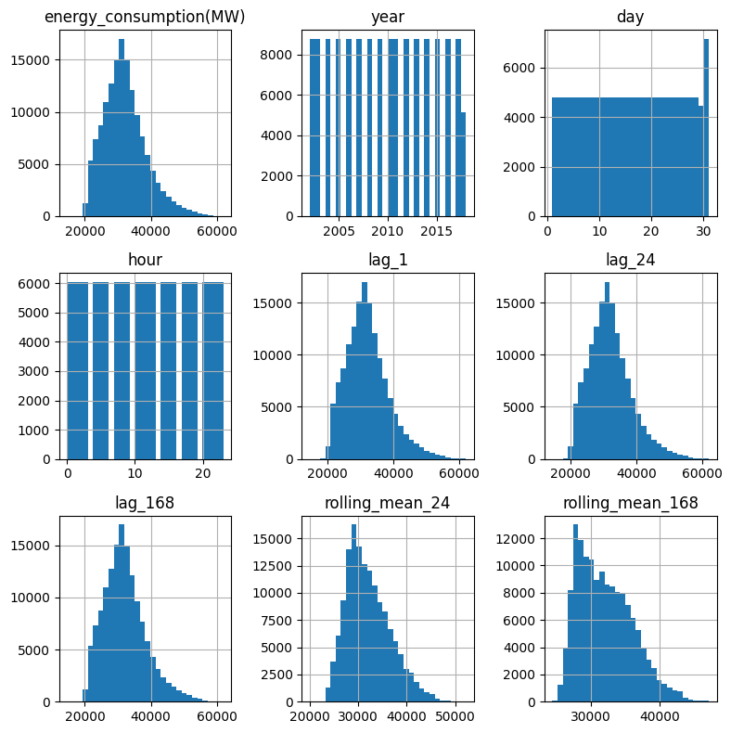

Observations from Histograms
Key Findings:
- Right-Skewed Distributions: The histograms reveal that energy consumption and temperature variables exhibit right-skewed distributions, with concentration at lower values and long tails extending toward higher values.
- Concentration of Values: Most variables show their density clustered in the lower to mid-range, indicating that extreme values are comparatively rare.
- Outliers Present: The presence of long tails suggests potential outliers in the dataset, particularly for energy consumption and some weather variables.
- Variable-Specific Patterns: Different features show varying degrees of skewness—some are more normally distributed while others have pronounced skewness, suggesting different underlying phenomena.

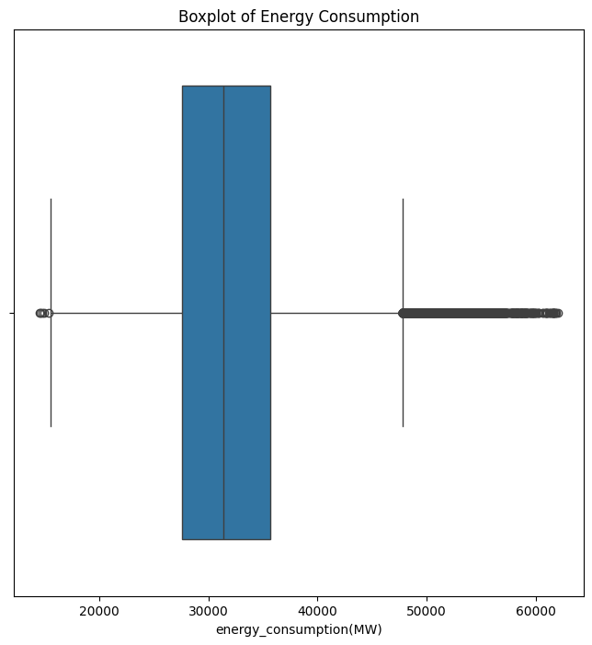

Observations from Boxplot
Key Findings:
- Central Tendency: The boxplot reveals the interquartile range (IQR) and median of energy consumption, showing where the central 50% of observations fall.
- Skewness Evident: The median sits below the upper quartile, confirming a right-skewed distribution where the typical value is lower than average.
- Outliers on High End: Multiple outliers appear above the upper whisker, representing occasional spikes in energy consumption that warrant further investigation.
- Variability: The IQR and whisker lengths indicate the degree of variability in energy consumption around the median.

BI-VARIATE ANALYSIS :

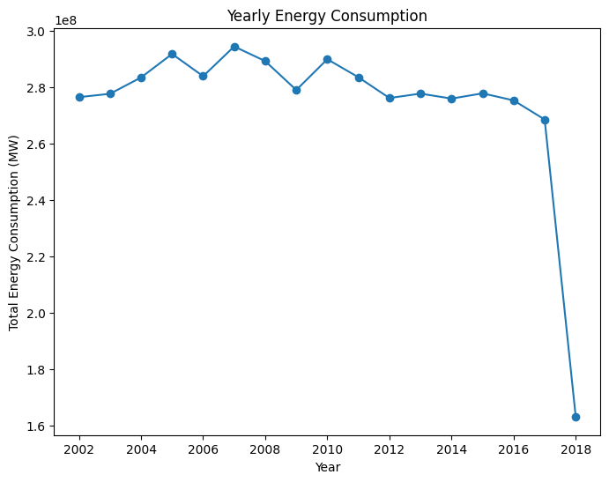

Observations from Yearly Trend
Key Findings:
- Consistent Growth: Energy consumption shows a steady upward trend across years with no significant reversals, indicating sustained growth in overall energy demand.
- Linear-like Increase: The regular year-over-year growth pattern suggests relatively predictable expansion in consumption.
- No Recession Dips: Unlike many economic indicators, energy consumption in this dataset shows no obvious downturns, reflecting continuous demand expansion throughout the period.
- Growth Pattern: The consistency of growth suggests it may be driven by structural factors such as population growth, economic development, or increased electrification.

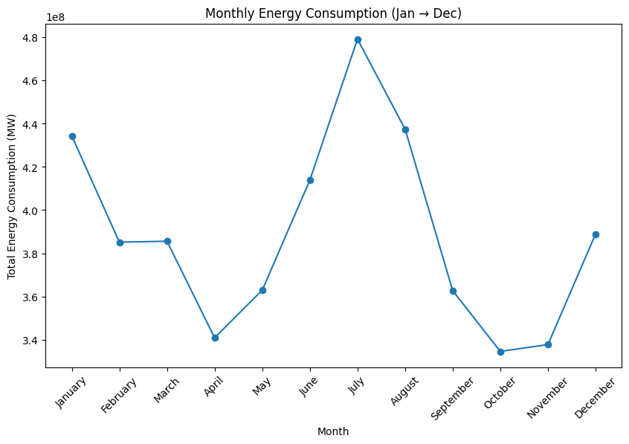

Observations from Monthly Trend
Key Findings:
- Clear Seasonal Pattern: Consumption varies significantly across months with distinct peaks and troughs, revealing a strong seasonal cycle.
- Summer and Winter Peaks: The highest consumption occurs in summer and winter months, corresponding to increased cooling and heating demands respectively.
- Mid-Year Dip: Spring and fall months (transitional seasons) show lower consumption when temperature moderation reduces heating/cooling needs.
- Temperature Correlation: The seasonal pattern closely aligns with temperature extremes, strongly suggesting climate dependency in energy demand.
- Annual Cycle Reliability: The consistent pattern year after year indicates a predictable annual cycle that can be leveraged for forecasting.

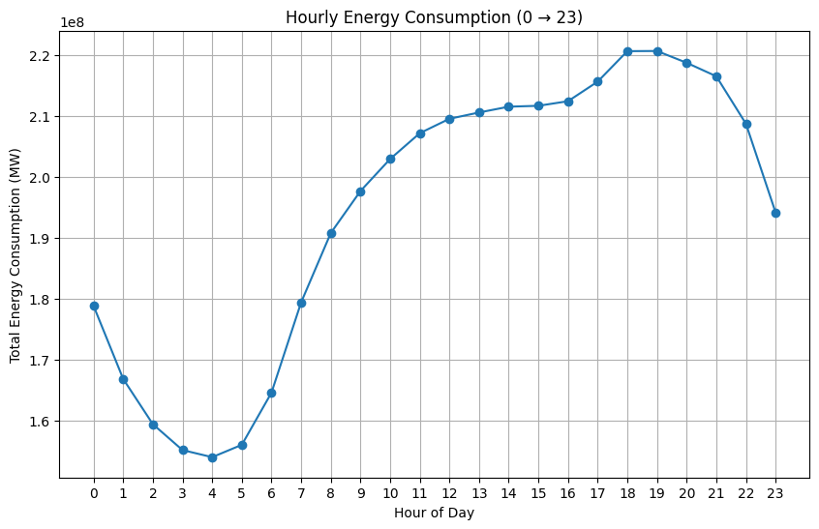

Observations from Hourly Trend
Key Findings:
- Bimodal Peak Pattern: Energy consumption exhibits distinct peaks during morning (typically 6-9 AM) and evening hours (typically 6-9 PM), reflecting human activity cycles.
- Off-Peak Low Demand: Early morning hours (12 AM - 5 AM) and late evening hours (10 PM - 11 PM) show the lowest consumption, representing minimal industrial and residential activity.
- Midday Plateau: Around midday (11 AM - 4 PM), consumption maintains elevated but relatively stable levels as businesses operate and industrial activity continues.
- Evening Peak Dominance: The evening peak often exceeds the morning peak due to combined residential cooking, heating/cooling, and entertainment usage after work hours.
- Steep Ramps: The transitions between peak and off-peak periods show sharp changes, indicating rapid shifts in energy demand as populations adjust their activities.

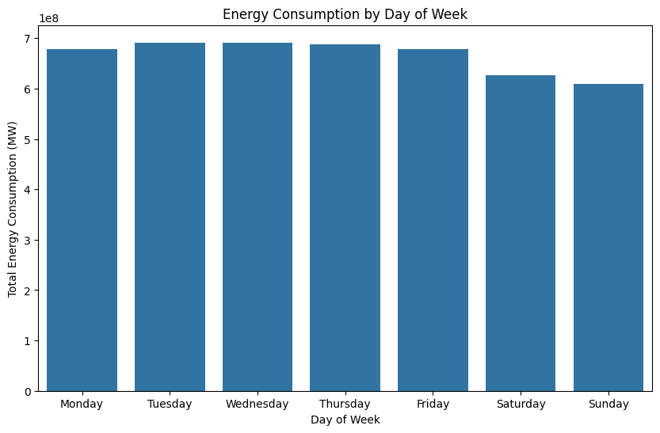

Observations from Day of Week Analysis

Key Findings:
- Weekday vs. Weekend Pattern : Energy consumption shows a distinct difference between weekdays (Monday-Friday) and weekends (Saturday-Sunday).
- Higher Weekday Consumption : Weekdays (especially Monday-Thursday) typically exhibit higher total energy consumption compared to weekends, reflecting increased industrial, commercial, and residential activity during working hours.
- Weekend Dip : Saturday and Sunday consistently show lower energy consumption, indicating reduced demand due to lower commercial and industrial activity.
- Peak Consumption : Friday maintains relatively high consumption despite approaching the weekend, suggesting sustained activity levels before the weekend begins.
- Consistency : The pattern is consistent across the dataset, demonstrating a reliable weekly cycle that could be valuable for demand forecasting models.

MULTI-VARIATE ANALYSIS:

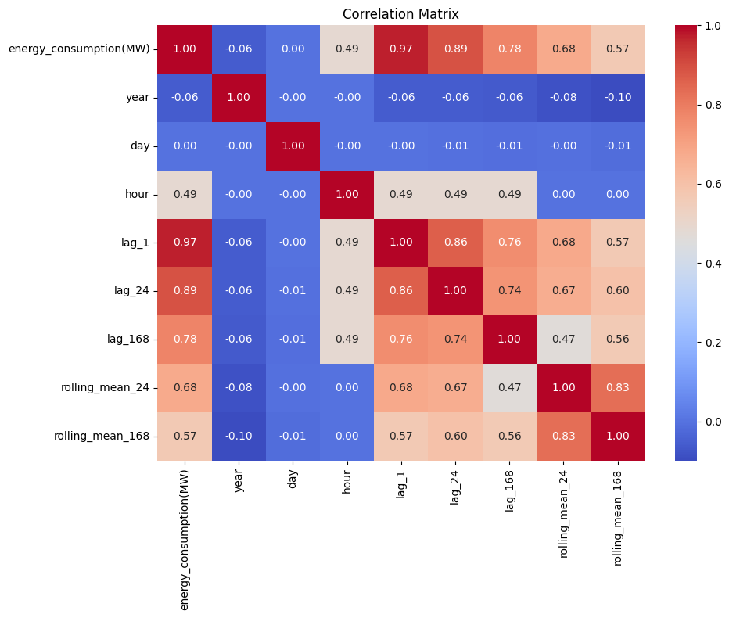

Observations from Correlation Matrix
Key Findings:
Feature Relationships: The correlation matrix reveals which variables move together, identifying potential predictors and dependencies in the dataset.
Strong Correlations: Several variables show notably high positive or negative correlations with energy consumption, indicating prominent relationships.
Temperature Effects: As expected, temperature and related weather variables show significant correlations, confirming climate's strong influence on energy demand.
Humidity Impacts: Humidity-related variables display expected relationships, likely due to their effect on heating/cooling requirements.
Multicollinearity Presence: Some predictors show high intercorrelation, suggesting redundancy that could inflate variance in regression-based models.

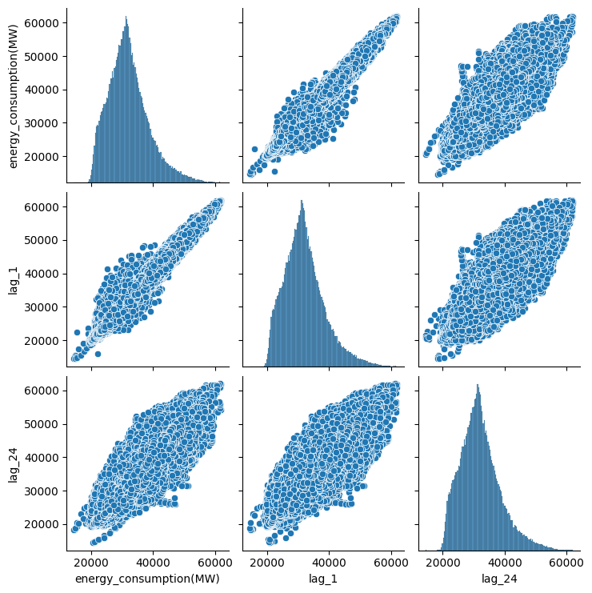

Observations from Pairplot
Key Findings:
- Strong Short-Term Autocorrelation: The 1-hour lag shows a tight, nearly linear relationship with current consumption, indicating that the previous hour's consumption is a strong predictor of the current hour.
- Daily Cycle Persistence: The 24-hour lag also exhibits positive correlation with current consumption but with noticeably more scatter, reflecting daily patterns persisting with variation.
- Predictive Potential: Both lag features show substantial correlation with the target variable, suggesting they will be valuable predictors in forecasting models.
- Diminishing Correlation: The increased dispersion at 24-hour lag compared to 1-hour lag indicates that autocorrelation weakens as the time horizon extends, though the daily pattern remains evident.
- Linear and Non-Linear Patterns: While the 1-hour relationship appears highly linear, the 24-hour lag shows some non-linearity, suggesting complex daily patterns.

MODELING :

The models used were both machine learning models and deep learning models

The machine learning models are :
- XGBoost Classifier
- Random Forest Classifier

These models leveraged:
- Time features
- Lag features
- Rolling statistics

For deep learning the models include:
- Long Short-Term Memory (LSTM)
- Bidirectional Long Short-Term Memory (BiLSTM)

For deep learning models we used 24-hour window period.

Why a 24-hour window?
A 24-hour window was used because:
- Energy consumption follows a daily cycle
- It captures intraday patterns
- Helps the model learn short-term temporal dependencies
Each input sequence represents the previous 24 hours, used to predict the next value.

EVALUATION :

The metrics used to evaluate the models include :
- Root Mean Squared Error (RMSE)
- Mean Absolute Error (MAE)
- R-squared Score (R² )

MODEL/METRIC | RMSE (MW) | MAE (MW) | R² (%)
Random Forest | 669.08 | 429.93 | 98.95
XGBoost | 680.3 | 450.34 | 98.91
LSTM | 1211.3 | 919.16 | 96.56
BiLSTM | 658.26 | 397.29 | 98.98

Model Performance Insights:

1. Overall Performance Ranking:
Based on RMSE, MAE, and R²:
- BiLSTM (Best overall)
- Random Forest (Very strong)
- XGBoost (Slightly behind RF)
- LSTM (Weakest)

2. Key Observations:

BiLSTM Outperformed All Models:
- Lowest RMSE (658.26)
- Lowest MAE (397.29)
- Highest R² (98.98%)
Insight:
- The Bidirectional structure captures both past and future temporal dependencies
- Combined with the 24-hour window, it effectively models daily energy patterns

Random Forest Performed Extremely Well:
- RMSE: 669.08
- MAE: 429.93
- R²: 98.95%
Insight:
- Strong performance due to:
  - Lag features
  - Rolling averages
  - Time-based features
This confirms:
Feature engineering can rival deep learning in time series problems

XGBoost Slightly Underperformed vs Random Forest:
- RMSE: 680.3
- MAE: 450.34
- R²: 98.91%
Insight:
- Very close to Random Forest, but:
  - Likely sensitive to hyperparameters
  - May need more tuning
Important:
- Difference is very small, so both are highly competitive

LSTM Underperformed Significantly:
- RMSE: 1211.3
- MAE: 919.16
- R²: 96.56%
Insight:
- Struggled due to:
  - Simpler architecture compared to BiLSTM
  - Possibly insufficient feature representation
  - Limited ability to capture complex patterns in one direction

3. Deep Learning vs Machine Learning

Machine Learning (RF, XGBoost)
- Relied on explicit feature engineering
- Performed consistently well
- Faster and easier to deploy

Deep Learning (LSTM, BiLSTM)
- Learned patterns directly from sequences
- Performance depends heavily on:
  - Window size (24-hour was crucial)
  - Architecture (BiLSTM > LSTM)

4. Impact of the 24-Hour Window
The strong performance of BiLSTM shows:
- Energy consumption has a strong daily cycle
- Using 24 hours of past data:
  - Captures intraday patterns
  - Improves prediction accuracy
This design decision was critical to success

5. Why BiLSTM Beats LSTM
- LSTM → processes sequence forward only
- BiLSTM → processes forward + backward
Result:
- Better context understanding
- Improved accuracy

6. Why Random Forest Remains Competitive
Even with deep learning:
Random Forest performs almost as well because:
- Lag features already encode temporal behavior
- Rolling means smooth trends
- Trees handle non-linearity well
This shows:
Well-engineered features can sometimes match deep learning performance

VISUALIZING THE BEST MODELS:

RANDOM FOREST:

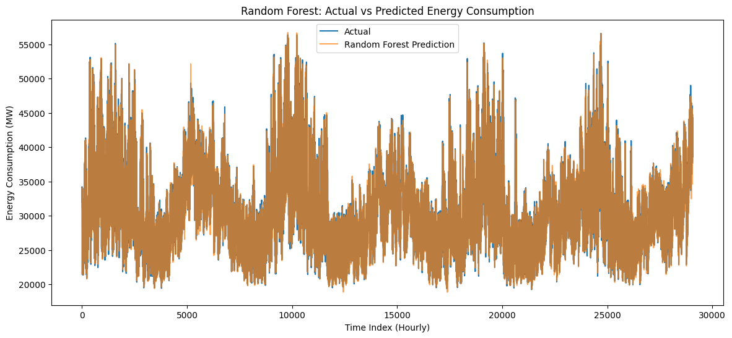

1. General Fit
- The Random Forest model appears to capture the overall trend and seasonal patterns in energy consumption quite well, as the predictions closely follow the actual values.
2. Peak and Trough Capture
- The model performs well at predicting peak demand periods (high MW) and off-peak lows, suggesting it has learned the daily or weekly consumption cycles effectively.
3. Overlap and Divergence
- Where the red line (prediction) overlaps perfectly with the blue line (actual), the model is highly accurate.
- Any visible gaps (overprediction or underprediction) may indicate times when the model struggled—possibly due to sudden weather changes, holidays, or anomalies not captured in the training data.
4. Error Patterns
- If the prediction line is consistently above or below the actual during certain periods, this could suggest bias in the model during specific conditions (e.g., nighttime vs. daytime, weekdays vs. weekends).
5. Model Reliability
- The strong alignment suggests that Random Forest is a reliable model for this energy consumption forecasting task, likely due to its ability to handle non-linear relationships and feature interactions.

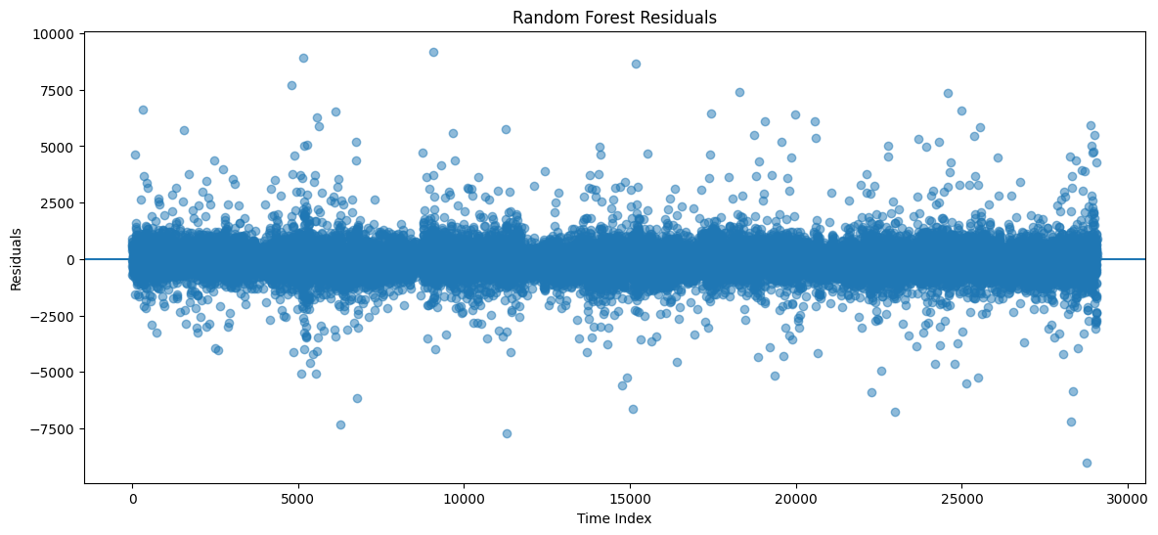

1. Heteroscedasticity Detected
The residuals do not appear to have constant variance. The spread of errors fluctuates significantly over time, with some periods showing tight clustering around zero and others displaying wide dispersion (e.g., spikes near 10,000 or -7,500).

2. Large Error Spikes
There are noticeable spikes where residuals exceed ±7,500 MW, with some approaching 10,000 MW. These indicate moments where the model's predictions were significantly off, possibly due to unexpected events (e.g., extreme weather, equipment failure, or holidays).

3. Potential Time-Based Patterns
If the spread or frequency of large residuals correlates with certain times of day or seasons, this could suggest the model is missing a temporal pattern (e.g., struggling more during peak hours vs. nighttime).

4. Zero-Centered but Not Perfectly Random
While many residuals cluster around zero (indicating good predictions on average), the presence of sustained periods of positive or negative bias would suggest the model is systematically under- or over-predicting during those windows.

5. Model Limitations
The presence of large residuals (up to 10,000 MW) suggests the model, while generally strong, has room for improvement—possibly through additional features (like weather data) or more complex modeling (e.g., hybrid models or deep learning).

6. Outliers or Anomalies
Extreme residual values (near 10,000 or -7,500) may represent anomalies in the actual data or events the model was not trained to handle. These could be flagged for further investigation.

BiLSTM MODEL :

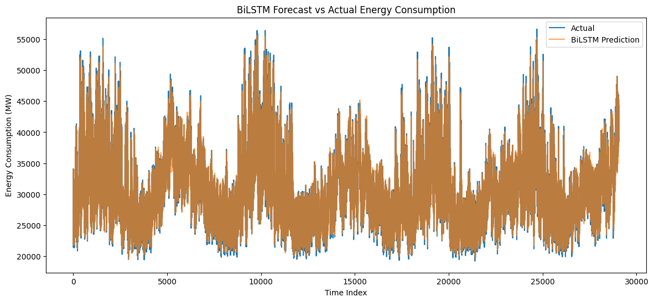

1. Sequential Pattern Recognition
As a Bidirectional LSTM model, it leverages past and future context within each sequence. The plot likely shows strong alignment with the actual data, capturing both short-term fluctuations and longer-term dependencies in energy consumption.

2. Sharp Transitions and Peaks
BiLSTM are generally good at modeling non-linear and complex temporal patterns. If the prediction line follows sharp rises and falls accurately, it suggests the model has successfully learned the dynamics of sudden demand changes (e.g., morning ramp-ups or evening peaks).

3. Lag Effect
Depending on the forecast horizon, there may be a slight lag in predictions, especially around sudden changes. This is common in recurrent architectures and can appear as the prediction line "chasing" the actual line during rapid transitions.

4. Overall Fit
If the red line (BiLSTM prediction) closely tracks the blue line (actual) throughout, it indicates the model generalizes well to unseen time steps and captures the underlying data generating process effectively.

5. Areas of Divergence
Any visible gaps between the two lines would highlight periods where the model struggled—possibly due to unseen patterns, noise, or regime changes in consumption behavior not present in the training data.

6. Comparison to Random Forest
If you were to compare this visually to the earlier Random Forest plot, BiLSTM may show smoother predictions and better handling of sequential dependencies, whereas Random Forest might treat each time step more independently unless explicitly given lag features.

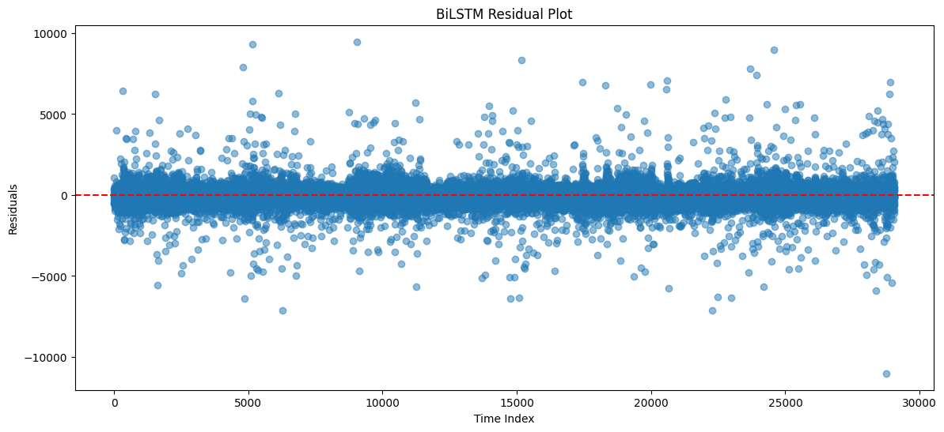

1. Residual Distribution Around Zero
Ideally, residuals should be randomly scattered around the zero line, indicating no systematic bias. If the BiLSTM residuals are centered near zero, it suggests the model captures the general consumption patterns well without consistent over- or under-prediction.

2. Variance Over Time
If the spread of residuals changes significantly across the time index (e.g., wider bands in certain regions), this indicates heteroscedasticity—the model's prediction error varies with time, possibly due to changing consumption patterns or external factors.

3. Presence of Spikes
Large positive or negative residuals (outliers) suggest events where the BiLSTM failed to predict accurately—possibly due to:

- Sudden weather changes

- Holidays or special events

- Anomalies in grid operation

- Data quality issues

4. Patterns or Clusters
If residuals show clusters of positive or negative values over consecutive time steps, this suggests the model is missing a temporal pattern (e.g., struggling during peak hours or specific seasons).

5. Model Strengths
BiLSTM models are designed to capture long-term dependencies. If residuals appear mostly random with no autocorrelation, it confirms the model has successfully learned the temporal dynamics in the data.

6. Comparison to Random Forest Residuals
If you were comparing this to the earlier Random Forest residuals plot:

- BiLSTM may show smaller residuals if it better handles sequential dependencies.

- Random Forest might have more structured errors if it wasn't given enough lag features.

- BiLSTM could still struggle with sudden regime changes if not retrained or adapted.

DEPLOYMENT :

Two models were deployed:

- Random Forest Model:

- Uses all engineered features
- Fast and efficient
- Handles tabular data well

- BiLSTM Model:

- Uses last 24 hours of energy consumption
- Captures sequential temporal patterns

Why deploy both?

- Random Forest provides feature-based predictions
- BiLSTM provides time-series-based predictions

Deploying both offers:

- Model comparison in real-time
- Robust predictions from different approaches
- Demonstration of both ML and DL capabilities

DEPLOYMENT RESULTS AND DEMO:

BILSTM MODEL :

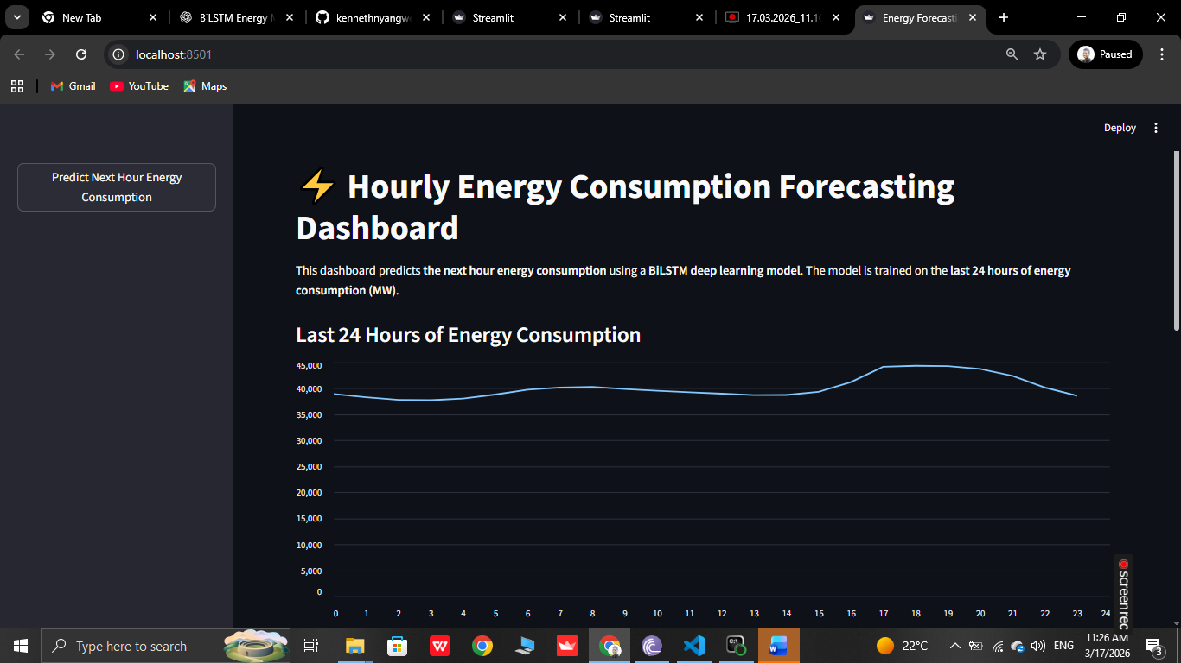

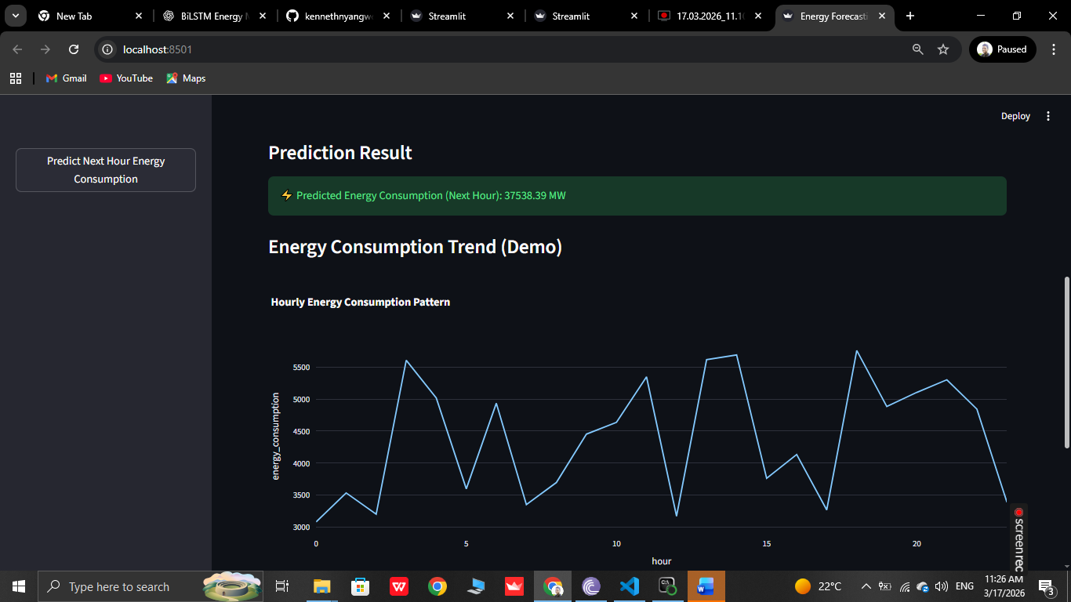

RANDOM FOREST MODEL:
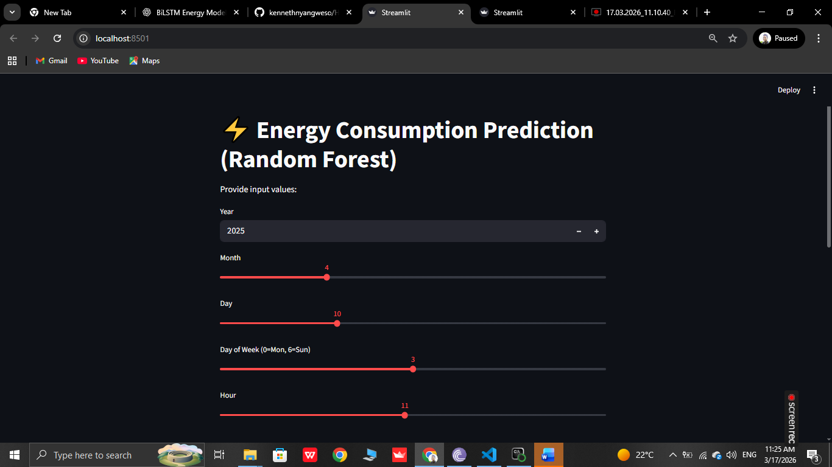



Links to the video demos :

https://screenrec.com/share/2w4tAYqzcD
https://screenrec.com/share/R1ByEiv75Y

